“The fear of the LORD is the beginning of wisdom,
And the knowledge of the Holy One is understanding.”
-- Proverbs 9:10

- Please show all your work! No partial credit will be given for incorrect answers with no work shown. Please draw a box around your final answer.
- Calculators are required. No notes, text, laptops, PDAs, or electronic dictionaries.
Cell phones should be muted and left in your pocket or bag.
- Tables 3, 4, 7, and parts of 6 are stapled to the back of this exam.
Total marks: 70

- Assume that the height of a population of kindergarten girls is normally distributed with standard deviation 5.2cm.
  - How many girls do we need to measure to estimate the mean height to within ±1cm with 95% confidence? [4]
95% conf => z = 1.96
1.96 = 1 / (5.2/sqrt(n))
n = (1.96*5.2)² ≈ 103.87
Measure 104 girls.
  - If we measure 20 girls, estimate the standard error of the estimate of the mean height of kindergarten girls. [2]
SE = 5.2/sqrt(20) ~= 1.16 cm
  - If we measure 2000 girls instead, estimate the standard error of the mean. [2]
SE = 5.2/sqrt(2000) ~= 0.116 cm
  - With a sample size of 2000, estimate the standard deviation of the 2000 measurements. [2]
About same as before: ~5.2 cm
- The concentration of sarcoplasmic calcium is measured in a sample of muscle cells from 21 patients. The 21 measurements have mean 6.35 micromolar and standard deviation 2.5 micromolar, with a median of 6.5 micromolar. From what we know, is the population distribution of sarcoplasmic calcium concentration likely to be normal? Why or why not? [2]
Yes, what we are given is consistent with a normal:
A small SD relative to the mean is consistent with having no negative values,
and the median is close to the mean.
- The birth weight of a sample of 44 premature babies is measured to have mean weight 5.3 lbs, with a standard deviation of 0.6 lbs.
  - Calculate the standard error of the mean birth weight of premature babies. [2]
SE = 0.6/sqrt(44) = 0.0905
  - Construct a 90% confidence interval on the population mean. [3]
Table 4 (90%, df=40): t = 1.684
Confidence interval is 5.3 ± 1.684(0.0905)
≈ (5.148, 5.452)
  - True or False (circle one): If we take another sample of 44 premature babies, there is a 90% probability that the mean birth weight of that sample lies within the interval found in (b). False [1]
  - True or False (circle one): We are only 90% sure that the mean birth weight of all premature babies is within the interval found in (b). True [1]
  - True or False (circle one): 90% of all premature babies will have a birth weight within the interval found in (b). False [1]
  - True or False (circle one): We are only 90% sure that the mean birth weight of these 44 babies is within the interval found in (b). False [1]

  - There is a hypothesis (H_{A}) that the mean birth weight of premature babies is less than 5.5 lbs. Do these data support that hypothesis? Use α=0.01. [4]
T = (5.5-5.3)/0.0905 =~ 2.211
Table 4 (df=40, one-tailed): 0.01 < p < 0.02
Fail to reject H₀:
No, the data do not support the hypothesis that
the mean birth weight is less than 5.5 lbs.

- To investigate the effect of m-chlorophenylpiperazine (mCPP) on appetite, five moderately obese men were given mCPP over a six-week period. Four other moderately obese men were given a placebo over the same period. The weight loss in kg for each man is summarized below:
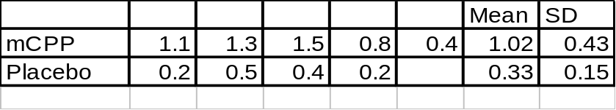
  - The question is whether mCPP has an effect on weight loss. State the null and alternative hypotheses, both in words and in notation using μ₁ , μ₂ , etc. [3]
H₀: μ_{mCPP} = μ_{P}
H_{A}: μ_{mCPP} ≠ μ_{P}
  - Calculate the standard error of the difference in sample means. [3]
SE_{mCPP} = 0.43/sqrt(5); SE_{P} = 0.15/sqrt(4)
SE = sqrt(0.43² / 5 + 0.15² / 4) ≈ 0.2074
  - Bracket (estimate) a p-value for this hypothesis test, using a t-test. Use df=6. [3]
t = (1.02 – 0.33)/0.2074 ≈ 3.35
Table 4 (df=6, two-tailed): 0.01 < p < 0.02
(computer shows p ≈ 0.01897)
  - State the conclusion of the t-test at a level of significance of α=0.02. [1]
Reject H₀
  - Interpret this conclusion in the context of the weight loss experiment. [2]
mCPP has an effect on weight loss.
  - Construct a 90% confidence interval on the difference of means between the mCPP and placebo populations. [3]
Table 4 (df=6, 90%): t = 1.943
(1.02 – 0.33) ± (1.943)(0.2074) ≈ (0.289, 1.091)
  - Now, use the Wilcoxon-Mann-Whitney test to bracket (estimate) a p-value for the same hypothesis test. [4]
K_{mCPP}=18.5, K_{P} = 1.5
Table 6 (n=5, n’=4, two-tailed): 0.05 < p < 0.10
  - State the conclusion of the Wilcoxon-Mann-Whitney test using the same level of significance, α=0.02. [1]
Fail to reject H₀
  - Interpret this conclusion in the context of the weight loss experiment. [2]
At α=0.02, there is insufficient evidence to show that mCPP has an effect on weight loss.
  - Compare and contrast the t-test with the Wilcoxon-Mann-Whitney test for this experiment. Which is more appropriate for this experiment? [4]
It’s hard to tell whether such small samples are normally distributed or not,
but there are no compelling reasons to doubt the validity of the t-test..
If the assumptions of the t-test are satisfied, it is more preferable over the WMW test, since it gives more statistical power: a smaller p-value.
- In another experiment, four moderately obese men are given a placebo over a six-week period, then given mCPP over another six-week period. The weight loss for each man during each period is given below:
Patient | Patient1 | Patient2 | Patient3 | Patient4
Placebo | 1.1 | 1.3 | 1.5 | 0.8
mCPP | 0.2 | 0.5 | 0.4 | 0.2
  - There are two groups of numbers, one for placebo and one for mCPP. Discuss whether a t-test on two independent groups is appropriate for this experiment. [1]
No; the observations are not all independent
  - Discuss whether a Wilcoxon-Mann-Whitney test on two groups is appropriate for this experiment. [1]
No; the observations are not all independent
- A study examines triglyceride levels both before and after a 7-week exercise program. The results from a sample are shown below.
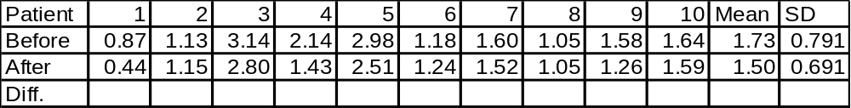
  - The question is whether exercise decreases triglyceride levels. State the null and alternative hypotheses, both in words and in notation using μ_{1,} μ_{2,} and/or μ_{d}. [3]
H₀: μ_{d} ≤ 0
H_{A}: μ_{d} > 0
  - Use a t-test to answer the question: find (bracket) the p-value. [4]
SE_{d} = 0.26/sqrt(10) =~ 0.0818
t-score = 0.23/0.0818 =~ 2.835
Table4(df=9, one-tailed): 0.005 < p < 0.01
(computer shows p =~ 0.009775)
  - State the conclusion to the t-test, using α=0.02. [1]
Reject H₀
  - Interpret this conclusion in the context of the exercise experiment. [2]
Exercise decreases triglyceride levels.
  - Now use a sign-test to answer the question: find (bracket) the p-value. [4]
N+ = 7, N- = 2
Table7(n=9, one-tailed): 0.05 < p < 0.10
  - State the conclusion to the sign-test, using α=0.01. [1]
Fail to reject H₀
  - Interpret this conclusion in the context of the exercise experiment. [2]
Insufficient evidence (using sign test)
to show exercise reduces triglyceride levels.

